CAR INSURANCE

create database 1BM21CS107_Insurance;

use 1BM21CS107_Insurance;

create table person

(

driver_id varchar(20) primary key,

name varchar(30) not null,

address varchar(50) not null

);



create table car

(

reg_num int primary key,

model varchar(50) not null,

year int not null

);

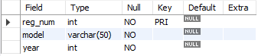

create table owns

(

driver_id varchar(50),

reg_num int,

primary key(driver_id,reg_num),

FOREIGN KEY (driver_id) references person(driver_id),

FOREIGN KEY (reg_num) REFERENCES car(reg_num)

);

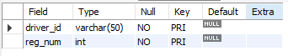

create table accident

(

report_num int primary key,

accident_date date not null,

location varchar(50) not null

);

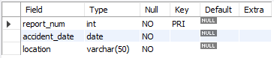

create table participated

(

driver_id varchar(50),

reg_num int,

report_num int,

damage_amount int not null,

primary key(driver_id,reg_num,report_num),

FOREIGN KEY (driver_id) references person(driver_id),

FOREIGN KEY (reg_num) REFERENCES car(reg_num),

FOREIGN KEY (report_num) REFERENCES accident(report_num)

);

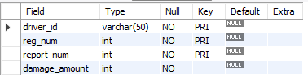

insert into person values

(

'A01',

'Mike',

'Central Park, New York'

);

